Geometry: Unit 6, Lesson 3

- What is an example of a transformation that preserves distance between vertices?

A reflection over the $y$-axis

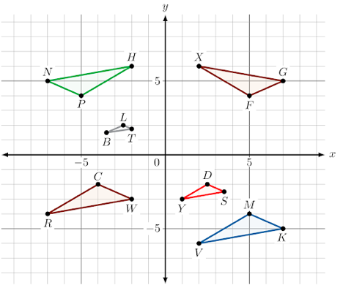
- Five transformations of $∆VMK$ are shown. What is NOT an example of pairs of congruent triangles?

$∆VMK$ and $∆YDS$

- What is an example of a transformation that preserves distance between vertices?

Dilation

